# | Type | DANCE | COSTUME | # OF STUDENTS | STUDENTS | STARTING CUE(S) | ENDING CUE(S)
1 | Acro | Christmas in Sarajevo | 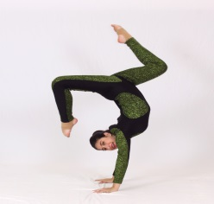 | 5 | Ashley Cavallo Danielle Grinberg Jordynn Larie Lila Pullo Nicole Fishman | PLACE in BLACK | FADE to BLACK
2 | Ballet | Someday Baby | 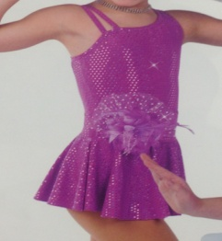 | 4 | Amare Hanson Cailin Duggins Isabella Delgado Victoria Toribo | MUSIC/LIGHTS  ENTER stage L | EXIT with music, stage L  NO BLACKOUT
3 | Acro | Footloose | 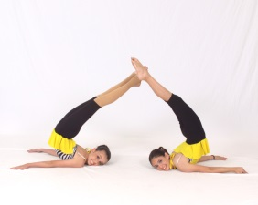 | 2 | Allie Lazar Kimberly Mulligan | ENTER with Music,  stage R & L | FADE to BLACK
4 | Acro | False King | 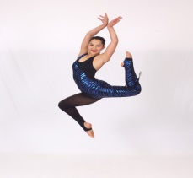 | 1 | Danielle Grinberg | PLACES in BLACK  (1/4 UPSTAGE L) | FADE to BLACK
5 | Ballet | Wouldn't It Be Lovely | Teal Dress  Teal Tutu  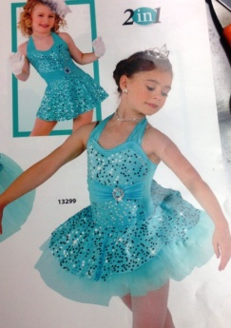 | 8 | Aaliyah Keen  Alyssa Gutierrez  Amelia Hanson  Ashley Kisslan  Chloe Caires  Jessica Hudak  Nia Imani Leandre  Tamara Faoor | MUSIC/LIGHTS  ENTER w/Music,  stage R & L | EXIT with Music, stage R  NO BLACKOUT  Semi – fade  (low lights)
6 | Acro | Mind Heist | Gold Unitard | 1 | Jordynn Lurie | Low Lights, then Music  ENTERS from stage R  Bring up lights | QUICK BLACK  (ON FOG HORN)
7 | *Ballet | Espana | Red& Black Tutu | 1 | Bailee Cudmore
8 | Salsa | Watch Out | Black/White | ? | Group including Danielle Grinberg
9 | Jazz Hip-Hop | Candy Kids | Multi Color Dress  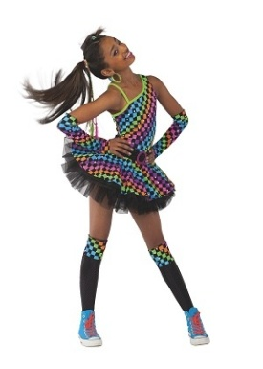 | 15 | Aaliyah Keen Allie Lazar Alyssa Gutierrez Amare Hanson Amelia Hanson Ariel Keen  Chassidy McNaughton  Elijah England  Kamila Delgado  Kimberly Mulligan  Marianna Gutierrez  Mikyle Millingen  Nia Imani Leandre  Vanessa Charles  Victoria Toribio | MUSIC/LIGHTS  ENTER with Music  stage R & L | EXIT with Music,  Stage R & L  FADE to BLACK
10 | Acro | Dream On | Blue  Multi-Color | 1 | Nicole Fishman | PLACES in BLACK  (upstage center) | FADE to BLACK  **CLOSE CURTAIN**
11 | Song | Popular | Red/Black Dress | 1 | Arianna Pereira | MICROPHONE  Sings in front of curtain  SPOT? | EXITS stage  FADE to BLACK
12 | Acro | Dead Silence | 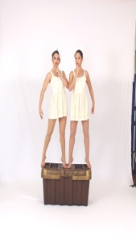 | 2 | Danielle Grinberg Jordynn Lurie | BEHIND the CURTAIN  PLACE BOX  Dancers PLACE in BLACK  OPEN CURTAIN  LIGHTS/MUSIC | AFTER “Giggle”  QUICK FADE to BLACK
13 | Tap | Let's Get Together | Lilac Dress | 4 | Amare Hanson Cailin Duggins Isabella Delgado Victoria Toribo | MUSIC/LIGHTS  ENTER w/Music, stage L | EXIT with TAG, stage L  FADE to BLACK  (as they EXIT)
14 | Acro | For A Moment | 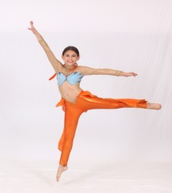 | 1 | Allie Lazar | PLACE in BLACK  (upstage Center)  MUSIC/LIGHTS | FADE to BLACK
15 | Acro | Amazing Mazie | 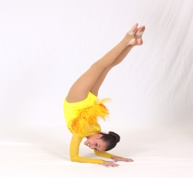 | 1 | Kimberly Mulligan | PLACE in BLACK  (upstage Center)  MUSIC/LIGHTS | FADE to BLACK
16 | Ballet | Stars and Stripes | Red, White and Blue Dress  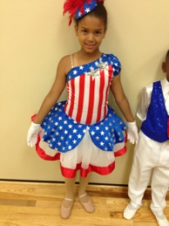 | 7 | Aaliyah Wilburn Amare Hanson Ariel Keen Brooke Caires Jasmine Waldman Mikaelah Smith Sofia Martinez | MUSIC/LIGHTS  ENTER w/Music  stage R & L | EXIT, stage R  FADE to BLACK
17 | Acro | La Bamba | Red and Black Dress  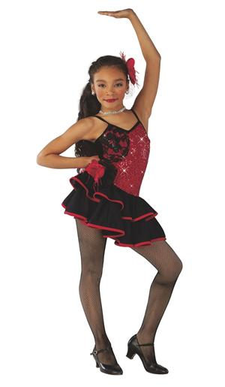 |  | Aaliyah England  Aaliyah Keen  Alyssa Gutierrez  Amelia Hanson  Ashley Kisland  Chassidy McNaughton  Jessica Hudak  Nia Imani Leandre  Tamara Faoor | PLACE in BLACK  MUSIC/LIGHTS | AFTER LAST TRICK  (Chassidy – tall student)  QUICK BLACK  Dancers move to NEW formation  LIGHTS UP  FADE to BLACK
18 | Acro | Cheetah Sister | 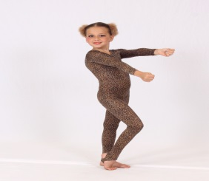 | 3 | Abigail Sanchez  Marialaura Espaillat  Mariapaola Espaillat | PLACE in BLACK  MUSIC/LIGHTS | FADE to BLACK  On 2nd “Cheetah Sister”
19 | Jazz | I Wanna Dance With Somebody | Blue Dress | 5 | Ashley Cavallo Danielle Grinberg Jordynn Larie Lila Pullo Nicole Fishman | MUSIC/LIGHTS  ENTER w/Music | FADE to BLACK  **PLACE ACRO MATS**
20 | Acro | Hi Diddly Dee | 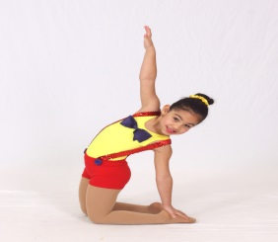 | 7 | Aaliyah Wilburn Amare Hanson Amelia Hanson Arianna Pereira Ariel Keen Mikyle Millingen Victoria Toribo | **PLACE MATS**  ENTER stage L  MUSIC/LIGHTS | EXIT with Music  MUSIC: Manual FADE?  FADE to BLACK  **STRIKE MATS**
21 | *Ballet | Paquita Variation | Pink & Black lace Tutu | 1 | Elyse Teheran
22 | Tap | Jitterbug | Teal Dress  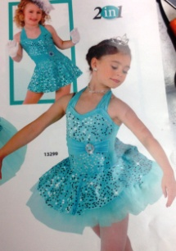 | 9 | Aaliyah Keen Alyssa Gutierrea Amelia Hanson Ashley Kisland Chloe Caires Jessica Hudak Kimberly Mulligan Nia Imani Leandre Tamara Faoor | MUSIC/LIGHTS  ENTER w/Music, stage L | EXIT with Music, stage R  FADE to BLACK
23 | Acro | Stampede | 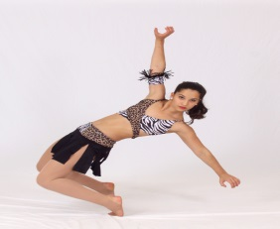 |  | Ashley Cavallo  Danielle Grinberg  Jordynn Lurie  Lila Pullo  Nicole Fishman | PLACE in BLACK  MUSIC/LIGHTS | FADE to BLACK  CLOSE CURTAIN
INTERMISSION
24 | Ballet | Dragon Dance | 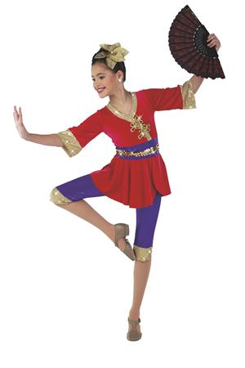 |  | Allie Lazar  Alyssa Gutierrez  Amelia Hanson  Ashley Cavallo  Danielle Grinberg  Jordynn Lurie  Joyce Charles  Kamila Delgado  Kimberly Mulligan  Lila Pullo  Marianna Gutierrez  Nicole Bopp  Nicole Fishman Paulina Castro | PLACE in BLACK  BEHIND CURTAIN  CURTAIN OPENS  (remain in BLACK)  MUSIC  THEN lights up (SLOWLY) | FADE to BLACK  ONCE in STRAIGHT LINE
25 | Tap | Yankee Doodle | Red, White and Blue Dress  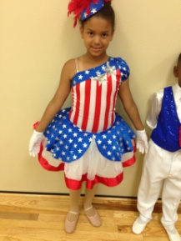 | 7 | Aaliyah Wilburn  Amare Hanson  Ariel Keen  Brooke Caires  Jasmine Waldman  Mikaelah Smith  Sofia Martinez | MUSIC/LIGHTS  ENTER w/Music, stage L | EXIT with Music, stage R  FADE to BLACK
26 | Acro | Girls Just Wanna Have Fun | Pink Unitard and Aqua Shirt  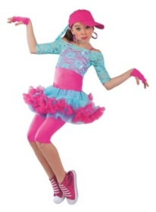 | 8 | Aaliyah Keen  Abigail Sanchez  Allie Lazar  Kimberly Mulligan  Marialaura Espaillat  Marianna Gutierrez  Mariapaola Espaillat Paulina Castro | PLACE in BLACK  MUSIC/LIGHTS | EXIT with music, stage L  MUSIC: Manual FADE?  FADE to BLACK
27 | *Ballet | La Chica Que Salta | Red/black long Spanish Dress | 1 | Kimberly Tran
28 | Song | Thank you for the Music |  | 1 | Arianna Pereira | MICROPHONE  ENTER  SPOT? | EXIT  FADE to BLACK
29 | Jazz | We're The Kids of America | 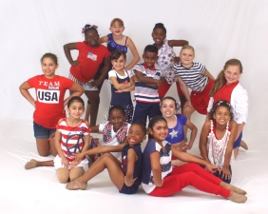 | 14 | Aalyiah Keen  Aaliyah Wilburn  Alyssa Gutierrez  Amare Hanson  Amelia Hanson  Ariel Keen  Ashley Kissland  Brooke Caires  Chloe Caires  Jasmine Waldman  Jessica Hudak  Kimberly Mulligan  Nia Imani Leandre  Tamara Faoor | MUSIC/LIGHTS  ENTER w/Music  stage R & L | EXIT with Music,  Stage R & L  FADE to BLACK
30 | *Ballet | Infernal | Orange/Green Tunics | 1 | Bailee Cudmore  Elyse Teheran  Kimberly Tran
31 | Contemporary |  | ? | 2 | Al’s group
32 | Tap | New York, New York | Black Pants and White Shirt  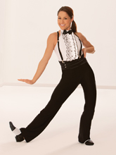 | 7 | Allie Lazar  Danielle Grinberg  Jordynn Lurie  Kamila Delgado  Kimberly Mulligan  Marianna Gutierrez  Nicole Fishman | PLACE in BLACK  MUSIC/LIGHTS | FADE to BLACK
ANNOUNCEMENTS/AWARDS
33 |  | FINALE |  | 7 | Ashley Cavallo  Danielle Grinberg  Jordynn Lurie  Lila Pullo  Nicole Fishman  Allie Lazar  Kimberly Mulligan Ms. Gina | ???  PLACE in BLACK  MUSIC/LIGHTS | FADE to BLACK
Note: *Courtesy of Ballet Elite

